**735/3**

**TECHNICAL**

**DRAWING**

**PAPER 3**

**JULY/AUGUST**

**3 HOURS**



**ELITE EXAMINATION BUREAU MOCK 2019**

**Uganda Certificate of Education**

**TECHNICAL DRAWING**

**PAPER 3**

3 HOURS

**INSTRUCTIONS TO CANDIDATES:**

* *You are provided with drawing paper A2. Use both sides of the paper where necessary.*
* *Attempt all questions in this paper.*
* *At the bottom right hand corner of your paper, draw a title block and on it print your;*
* *Names*
* *Subject paper and code*
* *Title of the building*
* *Date of examination*

Figure one (1) on page 4, shows a ground plan of a residential house.

The roof is hipped throughout.

**SPECIFICATIONS:**

ROOF: Hipped roof pitched at 30**0**

Iron sheets of gauge 28” are nailed on

75mm x 50mm purlins, on,

100mm x 50mm rafters, on,

100mm x 50mm stares and ties, on

150mm x 50mm tie - beam, on,

100 x 50mm wall plate.

The facial board is 200mm x 25mm.

WALLS: Both external and internal walls are 230mm thick constructed in English bond.

The height from finished floor to underside of wall plate is 3000mm.

Height from floor to ring beam is 2100mm.

The house is painted throughout.

DOORS: D**1**: 1200mm X 2100mm casement metallic.

D**2**: 900mm X 2100mm metallic door

D**3**: 900mm x 2100mm flush door.

WINDOWS: W**1**: 1600mm x 1200mm casement metallic

W**2**: 600mm x 600mm casement metallic

FLOOR: 30mm of terrazzo, on

100mm of oversite concrete, on

150mm of hard core stones

50mm of sand blinding

FOUNDATION: 690 X 230mm of concrete strip foundation at a depth of 900mm.

APRON: 600mm x 150mm of concrete.

**QUESTIONS:**

1. using the specifications and the provided plan in Figure 1, draw a free hand pictorial sketch of the building, with corner W in the fore ground.

2. To a scale of 1:75, draw;

a) The ground plan and insert the symbols.

b) Draw the sectional elevation X – X and name all parts of the roof and floor.

c) Project the rear elevation of the building.

3. To a scale of 1:10,

Draw a Tee – junction at any point of the building showing,

i) Two plans

ii) Isometric view.

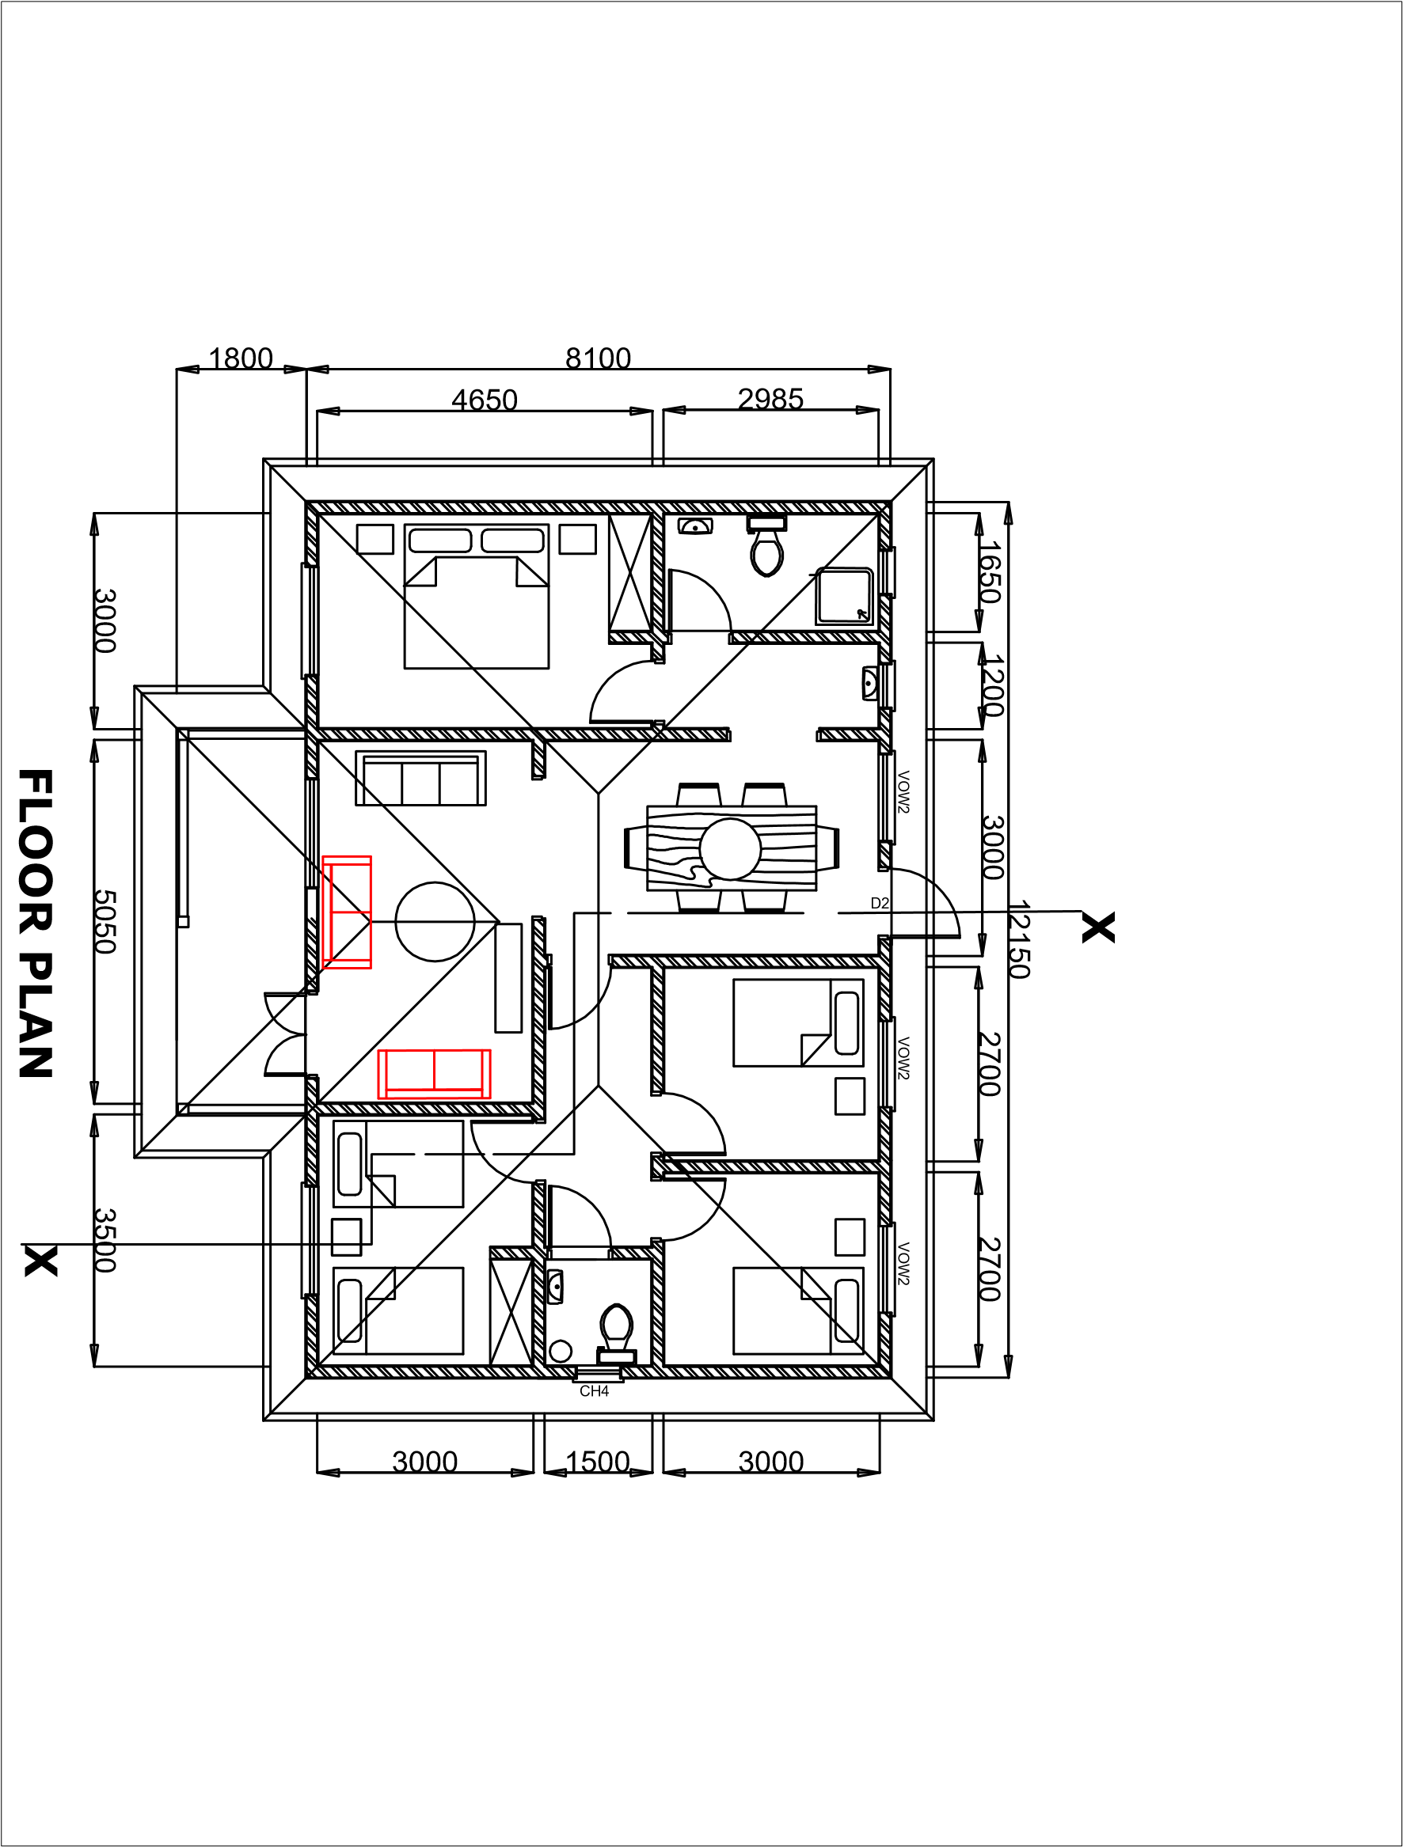

W

**END**